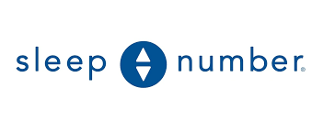

**Sleep Number Strategic Analysis**

**BUS 495**

**Dr. Swift**

**David Gray, Andrew Holmberg, CJ McBride, Chad Yannazzone, Dahmir Young**

**5/1/2023**

**Table of Contents**

**I. EXECUTIVE SUMMARY Page 3**

**II. INTERNAL AUDIT Pages 4-8**

**III. EXTERNAL AUDIT Pages 9-15 IV. STRATEGIC ISSUES Pages 15-16**

**V. STRATEGIC CHOICES Pages 16-17**

**VI. STRATEGIC OBJECTIVE Pages 17-18**

**VII. STRATEGY IMPLEMENTATION Pages 18-19**

**VIII. FINANCIAL FORECASTING Pages 19-25**

**IX. CONCLUSION Pages 25-26**

**X. APPENDIX Pages 27-39**

**XI. BIBLIOGRAPHY Pages 40-42**

I. EXECUTIVE SUMMARY

The following is a strategic analysis of the Sleep Number Corporation that identifies the key strategic issue facing Sleep Number, proposes potential strategic choices to remedy the issues, and provides a robust forecast of the proposed strategic choices with objectives. The increased societal interest in shopping for mattresses online, combined with technological developments driving consumers towards shopping online, has put Sleep Number in a position where they must increase online sales of their mattresses to meet customer’s demands and protect themselves against the changing mattress market landscape. The strategy identified in remedying this issue is an omnichannel approach to increasing Sleep Number’s online percentage of revenue. This approach includes increased presence in hotels to remove the need for customers to “try-and-buy” in our retail locations, partnering with Amazon for increased visibility online, and launching a new mattress with no technology embedded that does not require customers to “try-and-buy.” The objectives we have set are to increase our online sales from 14% percent to 25% in five years without negatively impacting net income. This strategy is forecasted to have a net present value of $269 million.

II. INTERNAL AUDIT

Company Overview

Sleep Number Corporation and its subsidiaries specialize in providing sleep solutions and services throughout the United States [1]. The company is involved in various aspects of the bedding industry, including designing, manufacturing, marketing, retailing, and servicing a wide range of products, such as beds, pillows, sheets, and other bedding essentials under the Sleep Number brand [1]. In addition, it offers adjustable bases under the FlextFit name and smart beds under the Sleep Number 360 label [1]. The company distributes its products through several channels, including direct-to-consumer retail, online, phone, chat, and e-commerce activities [2]. Previously known as Select Comfort Corporation, the company officially changed its name to Sleep Number Corporation in November 2017 [1]. Since its inception in 1987, the company has been headquartered in Minneapolis, Minnesota, and is currently under the leadership of CEO Shelly R. Ibach [1].

Mission Statement Evaluation

Sleep Number’s mission statement is: “To improve lives by individualizing sleep experiences.” [3] This mission statement does help to understand and contextualize some of Sleep Number’s recent actions. In recent years, Sleep Number has focused on developing new technologies to increase the customization of their customer’s sleep experience. This is exemplified by innovations such as SleepIQ technology which tracks sleep patterns and offers personalized recommendations for improving sleep quality [4]. However, the brevity of the mission statement leads to it being relatively vague. The mission statement provides no detail about the company itself, how it plans on individualizing sleep experiences, or whose lives the company hopes to improve.

The mission statement of Sleep Number has the potential to build shared purpose among employees. The mission statement emphasizes a common goal of improving lives, which can create a sense of shared purpose among employees who are working towards that goal. That said, it would be difficult for an employee to align themselves with the values of the company from the mission statement alone. The statement is too brief to gather what the company’s core values are, which inhibits employees’ ability to rally behind a shared purpose through shared values [5].

Sleep Number’s mission statement will struggle to create consensus among stakeholders. While the focus on improving lives may resonate with customers and employees, the mission statement is less likely to create consensus among shareholders who will be more interested in how the company plans to create financial value.

Sleep Number’s mission statement is aspirational in its focus on improving lives and commitment to individualization, however the statement does not translate these aspirations into concrete actions and behaviors. Overall, the mission statement will benefit from including these specific and tangible actions to provide more detail, help build shared purpose among employees, and create consensus among all stakeholders.

Business Scope

Sleep Number offers smart mattresses, bedding, pillows, and furniture. Sleep Number mattresses offer the ability to adjust the temperature and firmness, sense one’s movements to contour to the body, provide insight into one’s sleep quality, and responsively raise and lower the head to mitigate snoring [6]. These technological offerings contribute to Sleep Number’s comparably high average revenue per mattress unit of $5,403 in 2022 [2]. For comparison, the industry-average price for a queen-size innerspring mattress in 2021 was $1,050 [7].

Sleep Number has an exclusive direct-to-consumer distribution model where they are the exclusive distributor of their products through their own website and their own portfolio of retail stores [2]. As of December 31, 2022, Sleep Number operates 670 retail locations with there being at least one location in all 50 states [2]. Sleep Number does not operate any stores internationally, nor does it deliver any of its products sold online to outside of the United States [8]. The two markets with Sleep Number’s largest retail presence in terms of number of stores are California, with 74 stores, and Texas, with 61 stores [2].

SWOT Analysis

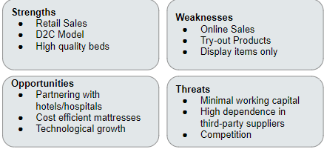

*Strengths*

Sleep Number’s sales are skewed towards retail sales over online sales compared to the rest of the industry. Sleep Number generates 86% of its overall sales from its retail sales [9]. This can be compared to the industry average of 50% [10]. Sleep Number does not offer their mattresses on any third-party websites or retail locations. This allows Sleep Number to have complete control over the customer’s experience when purchasing one of their products. The degree to which technology is implemented in Sleep Number’s mattresses causes a significant price difference between their mattresses and the industry average, but it also allows for a higher gross profit margin compared to their main competitors.

*Weaknesses*

While Sleep Number’s high percentage of retail sales can be seen as a strength, their low percentage of online sales can be seen as a weakness. The rest of the mattress industry does approximately 50% of its sales compared to Sleep Number’s 14% [10] [9]. Another weakness of Sleep Number is the necessity for customers to “try-and-buy” Sleep Number mattresses. Smart mattresses have a substantial amount of technology embedded in them that customers will likely have to try out before they fully commit to purchasing the product. This need also begins to explain why Sleep Number’s online sales are so low compared to the industry average. Sleep Number’s retail locations are used to allow customers to try the products and serve more as showrooms and do not carry purchasable inventory [2]. The mattresses are made-to-order and as such have an average lead time of two weeks [2]. This can be seen as a weakness as Sleep Number will be unable to fulfill the needs of a customer who needs a mattress sooner.

*Opportunities*

Partnering with hotels presents a significant opportunity for Sleep Number. Hotel partnerships improve visibility and serve as marketing, so these relationships are important for mattress manufacturers throughout the industry. These relationships can be especially beneficial for Sleep Number because of the necessity for customers to “try-and-buy.” Hotels serve as a location other than Sleep Number’s retail stores where customers can try the product before they buy it.

*Threats*

One threat that Sleep Number faces is their dependency on third-party suppliers. Sleep Number sources all of the compartments and parts for its smart beds from third-party suppliers, which can make them especially vulnerable to price changes and supply chain disruptions [2]. This threat may be felt more so by Sleep Number than their competitors as Sleep Number has more electronic components in their mattresses and as such are more likely to experience supply chain disruptions at any given time.

Core Competencies and Competitive Advantage

Sleep Number establishes itself as the differentiator because they have a higher gross profit margin at 57.38%, as opposed to Tempur-Sealy’s 42.50% (see graphic below). Sleep Number is also the cost leader as they have a slightly higher total asset turnover at 2.24, whereas Tempur-Sealy has a total asset turnover of 1.17. The basis for Sleep Number’s high total asset turnover is their significantly higher current asset turnover compared to their competitor. Two large components of current assets are inventory and cash. Sleep Number keeps a very low level of inventory due to their made-to-order distribution model and keeps a very low cash balance by regularly draining it for stock buybacks [2]. Although Sleep Number is the cost leader and cost differentiator, they do not have a competitive advantage over Tempur-Sealy. This is true because Tempur-Sealy has a higher return on assets at 12.17%, as opposed to Sleep Number’s 5.65%. Sleep Number can also be identified as a broad differentiator, as they are targeting most mattress buyers and offer mattresses that are differentiated with their advanced technology.

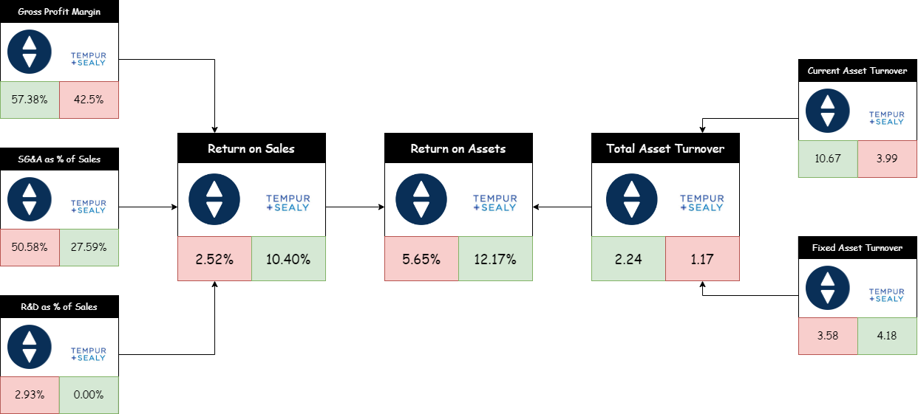

III. EXTERNAL AUDIT

An external audit analyzes and evaluates a company’s environment. This external audit will evaluate Sleep Number’s task environment using Michael Porter’s Five Forces framework and Sleep Number’s macro environment using the PEST framework.

Five Forces Framework

*Power of Suppliers*

Sleep Number acquires all of the parts and components that it uses to produce its smart beds from outside sources [2]. In some cases, these outside sources serve as the only source of supply for the particular part or component. Sleep Number indicates in their financial reporting that this is the case for their air chambers and certain electronic components [2]. While Sleep Number speculates that they could find an alternative source in the event of a disruption, they still acknowledge that it could present difficulties for the company [2]. It also makes Sleep Number more vulnerable to their suppliers raising prices. The power of suppliers may be less so for Sleep Number’s competitors in the mattress industry; as mattresses with less technology embedded in them are less likely to have electronic components for which the company has only one supplier.

*Power of Customers*

One of the main ways that customers can gain power is their ability to shop around for the lowest price. Fortunately for Sleep Number, the majority of times when a customer purchases a Sleep Number mattress, it is done in a Sleep Number store. The only retail locations that Sleep Number mattresses are sold in are Sleep Number stores, and 86% of the company’s net sales were done in retail locations. This means that the vast majority of Sleep Number’s sales are happening at their own retail locations. In this environment, the customer is unable to shop for lower prices from other brands because there is only one brand being sold. The easiest place to shop for the lowest price would be online, and online sales make up a very small percentage of Sleep Number’s net sales. By doing most of their business in environments where customers can not shop for the lowest price, Sleep Number is able to limit the power that customers have over the business.

*Substitute Products*

Sleep Number’s core product is the mattress and currently there is a lack of suitable substitutes that consumers could buy in its place. Some potential substitutes are air mattresses, futons, and sofa beds. While futons may be more prevalent in certain international markets, mattresses still hold the larger market share in the United States. While air mattresses are popular in the United States, mattresses are still the most popular permanent tool for sleeping. The dominance of mattresses over the air mattress substitute is evidenced by the total market size for each. In the United States the market size for air mattresses is $45 million [11]. By contrast, the market size for mattresses in the United States is about $12 billion [12].

*Competitive Rivalry*

Sleep Number leads its top competitor, Tempur-Sealy, as a differentiator. Sleep Number is a differentiator because we have a higher gross profit margin. Sleep Number has a gross profit margin of 57.38%. Tempur-Sealy has a gross profit margin of 42.50%. In addition, Sleep Number is a cost leader due to higher asset turnover. Sleep Number currently has asset turnover of 2.24. Tempur-Sealy currently has asset turnover of 1.17. Tempur-Sealy’s return on assets of 12.71% compared to Sleep Number’s return on assets of 5.65% indicates that Tempur-Sealy has the competitive advantage.

*Threat of New Entrants*

New entrants present a moderate threat to Sleep Number in the bedding industry. For the most part, the bedding industry is dominated by nationally recognized brand names; examples are Stearns & Foster, Serta Simmons, and our main competitor Tempur-Sealy [2]. In the brick-and-mortar retail arena, newer brands that started online are becoming new entrants; examples are Purple, Caspar, and Nectar [2]. There are very low barriers to entry in the online mattress manufacturing industry. Seth Basham, an expert on the mattress industry at Wedbush Securities, says, “It doesn’t take that much to design a mattress, a marketing campaign, put up a website, and have one of these big companies like Carpenter to do the fulfillment for you.” [13] However, the barriers of entry in brick-and-mortar for mattress manufacturers are much higher, as it is mainly dominated by the large, established manufacturers [2]. One additional struggle for new entrants in terms of visibility is acquiring contracts to have your mattresses placed in large hotel and resort chains. These relationships are often long standing with lengthy contracts; Sleep Number has been under contract with Radisson Hotel Group since 2004 and The Westin Hotel (owned by Marriott) has been using mattresses from Serta-Simmons since 1999 [14] [15].

|  |  |  |
| --- | --- | --- |
| **Force** | **Summary** | **Score (out of 5)** |
| Power of Suppliers | Sleep Number has only one supplier for certain electronic components | 4 |
| Power of Customers | Most of Sleep Number’s revenue comes from their own retail locations, where customers can’t shop for other brands | 2 |
| Substitute Products | Lack of suitable mattress substitutes | 1 |
| Competitive Rivalry | Sleep Number is a differentiator and cost leader, but does not have competitive advantage | 2 |
| Threat of New Entrants | While there are minimal barriers of entry for online mattress manufacturers, brick-and-mortar retail is more difficult to break into | 2 |
|  | **Total Score:** | **11/25** |

PEST Framework

*Political Factors*

Sleep Number is particularly vulnerable to political unrest, instability, or geopolitical turmoil that results in disruption of the supply chain [2]. Sleep Number operates with a made-to-order distribution model, where practically no assembled mattresses are kept in inventory and the retail locations only serve as showrooms rather than keeping an actual stock of mattresses. This model allows Sleep Number to keep its asset turnover extraordinarily high but puts the company at greater risk in the event of a supply shortage. Whereas other companies may have a stock of mattresses to deplete in the event of a shortage, Sleep Number will have to delay orders from the onset of the shortage. This was seen in full effect in 2022 when Sleep Number was directly affected by the chip shortage [16].

*Economic Factors*

Sleep Number’s sales and profitability depend greatly on how current economic conditions are affecting consumer discretionary spending [2]. While mattresses are an essential good, Sleep Number mattresses are a luxury version of it; this is indicated by Sleep Number’s average cost of a mattress of $5,403 compared to the industry average cost of a mattress of $1,050 [2] [7]. Therefore, when general economic sentiments are lower, consumers will be less likely to opt for a Sleep Number mattress over a cheaper alternative. In addition, the historically high recent levels of inflation have forced Sleep Number to pass on some of their increased costs to their customers in the form of raised prices [2]. Increased prices for Sleep Number in an inflationary environment will continue to incline customers to choose cheaper mattresses over the higher cost smart mattresses that Sleep Number offers.

*Social Factors*

A social trend anticipated to have an impact on the future of Sleep Number is the increasing number of Americans who prefer to do their shopping online. Since the first quarter of 2010, the share of total United States retail sales that are being done online has been steadily increasing (data shown in figure below) [17]. This is particularly concerning for Sleep Number, as online sales account for only 13.7% of Sleep Number’s revenue [2]. In a mattress industry where sales are approximately 50% online, Sleep Number is struggling to find market share in the ecommerce space [10]. If the trend of increasing online sales were to continue for the mattress industry, and Sleep Number is unable to grow their online market share, Sleep Number’s overall share of the mattress industry would begin to decline.

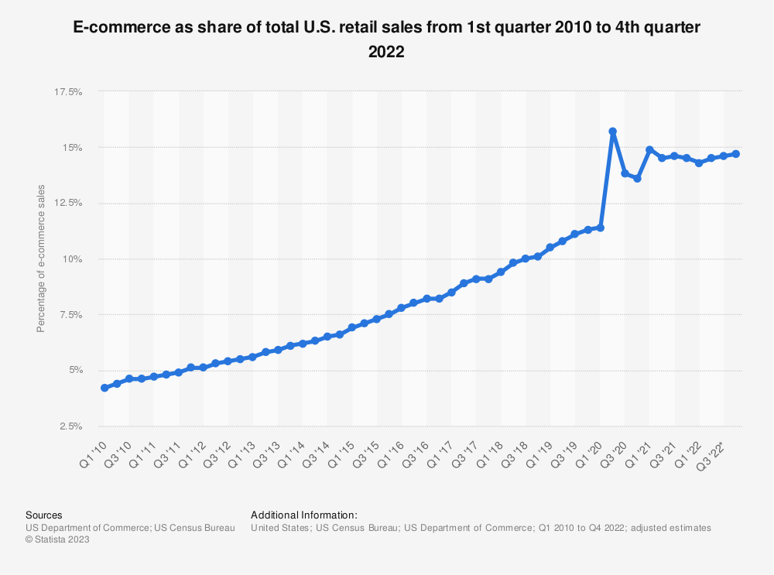

*Technological Factors*

The technological environment of the United States is also pushing consumers to expand the amount of shopping that they do online. Technological improvements are continuing to make it easier for customers to make their retail purchases online. This can be seen through the rise of mobile retail sales as a percentage of online retail sales. This percentage has also been steadily increasing over the past 6 years as indicated in the figure below [18]. Newer technologies are making shopping online even easier and more enticing for consumers. If this trend continues, it will become even more important for Sleep Number to capture as much of the online mattress market as they can now to protect their overall mattress market share into the future.

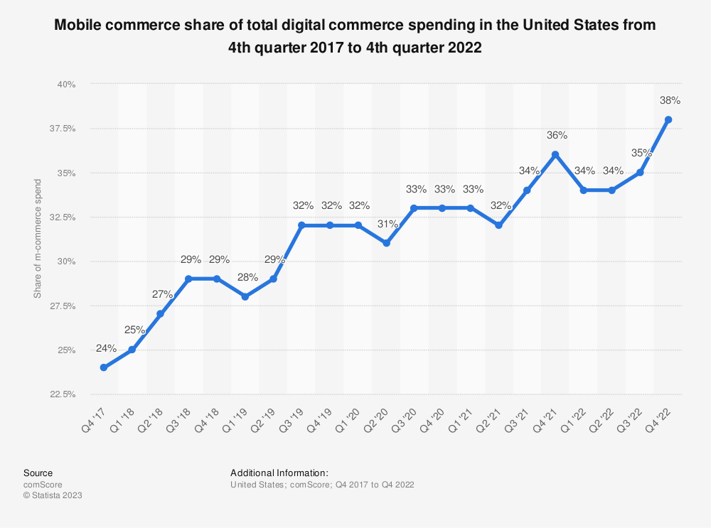

IV. STRATEGIC ISSUES

The identified key strategic issue facing Sleep Number is the limited success in online sales relative to its strong performance in brick-and-mortar retail. Retail sales are the main driver for sales and profit as 86% of our sales come from retail sales. With this being said, Sleep Number has a significant weakness in that only 14% of their revenue comes from online sales [9]. Sleep Number’s social environment indicates that American consumers are preferring more and more to do their shopping online. Sleep Number’s technical environment also indicates that online shopping is progressively becoming easier, especially with the rise of mobile ecommerce. With these two factors in mind, it is critically important that Sleep Number expands its share in the online mattress market immediately. Sleep Number needs to protect their share of the overall mattress market as the online percentage of the overall mattress market continues to grow.

V. STRATEGIC CHOICES

The first strategic choice recommended for Sleep Number is partnering with the largest online retailer, Amazon [19]. If Sleep Number are able to get their products on the largest online retailing platform, it can greatly increase their online visibility and drive up online sales. Amazon's pre-established e-commerce system will provide Sleep Number with guaranteed reach to audiences with which Sleep Number has struggled to reach thus far. The implementation of this strategic choice will take away Sleep Number’s strength of having complete control of the customer experience. Sleep Number has traditionally only sold their mattresses in their own retail stores and on their own website, which allows them to entirely dictate how customers interact with and purchase their products [2]. Selling on a third-party ecommerce platform like Amazon will remove this strength, but it may be a necessary concession in order for Sleep Number to hold their market share in a mattress industry that is increasingly taking place online.

A second strategic choice recommended for Sleep Number is to launch a new mattress-in-a-box product. A major weakness for Sleep Number is the necessity for customers to “try-and-buy” their mattresses. The degree to which technology is embedded in Sleep Number mattresses encourages customers to want to try out the new technology before making a purchase. This necessity is believed to be in part what is driving the majority of Sleep Number sales towards retail locations where customers can try the products. A simpler, mattress-in-a-box product would circumvent this need by having less technology embedded and allowing customers to confidently be able to purchase the product online without the need to try it in store. The internal and external analyses have also revealed that there are several electronic components in Sleep Number mattresses for which Sleep Number currently has only one supplier [2]. This puts Sleep Number at a significant risk for having supply chain disruptions [2]. A simpler mattress without technology will ensure that Sleep Number still has a significant source of revenue even in the face of supply chain issues for their electronic components.

A third strategic choice recommended for Sleep Number is to win more contracts to have their mattresses placed in additional hotels and resorts. These contracts are valuable for mattress companies because they serve as a marketing tool that helps to increase brand exposure. The additional value they present to Sleep Number is that they also allow customers to circumvent the “try-and-buy” process in Sleep Number retail stores. Consumers would be able to test Sleep Number products during their stay at the hotel, rather than at a Sleep Number retail location. Once a customer in a hotel has gotten to test out all of the technological features that a Sleep Number mattress has to offer, they can more confidently be able to make the purchase online without the need to visit a retail location. Contracts with hotels and resorts can also allow Sleep Number to continue to protect themselves against new entrants. These contracts tend to be lengthy as evidenced by Sleep Number’s 20-year relationship with Radisson Hotel Group [15]. By not allowing any new entrants to get any of the hotel contracts that are becoming available, Sleep Number can guarantee far into the future that their brand will continue to have higher visibility in the hospitality industry.

VI. STRATEGIC OBJECTIVE

Sleep Number aims to increase online sales from 14% to 25% of total revenue in 4 years without seeing any decrease in net income. This objective was developed using the SMART framework to be specific, measurable, attainable, relevant, and time-bound. Online sales as a percentage of revenue is measurable and reaching the milestone of 25% is specific. This objective is shown to be attainable in the financial forecast that follows in this report. Online sales as a percentage of revenue is the most relevant statistic to Sleep Number shifting more of their business to the online space. This objective is time-bound as it must be met within 4 years.

VII. STRATEGY IMPLEMENTATION

Sleep Number produces its mattresses on a made-to-order basis [2]. With this in mind, it makes most sense for Sleep Number to use Amazon’s fulfillment service, so that the company does not need to handle the storage of their mattresses or shipping them to the final customer. With Amazon’s fulfillment service, Sleep Number will only have to ship mattresses periodically to Amazon fulfillment centers which will likely correspond to a lower cost than what Sleep Number currently undergoes in shipping to the end consumer because it will be done in bulk. For this financial forecast the worst-case scenario is assumed that these costs are equal. Sleep Number’s added costs for selling on Amazon will be Amazon’s category-specific referral fee. Using Amazon’s revenue calculator, the cost of Amazon’s category-specific referral fee is 15% for mattresses [20]. Large vendors on Amazon, which Sleep Number will be, are able to confidentially negotiate with Amazon to lower these referral fees [21]. Because of how confidential these negotiations are, it is difficult to determine what Sleep Number’s actual referral fee would be. For this forecast it is estimated to be 3%. Because the referral fee covers the advertisement of Sleep Number products on Amazon’s site and costs related to search engine optimization (SEO), the Sales and Marketing expenses incurred from revenue earned from the Amazon partnership are forecasted to be less than that of what they typically are. Since SEO costs account for about 9.5% of digital marketing expenditure in the United States, the revenue earned from the Amazon partnership is forecasted to have Sales and Marketing expenses that are 9.5% lower than revenue from all previous channels [22].

In 2022, Sleep Number developed three new products: the Climate360 Smart Bed, the Sleep Number Lifestyle Collection furniture, and the Sleep Number smart bed ecosystem. Given that Sleep Number had $62 million in Research and Development expenses in 2022, it can be estimated that Sleep Number spends $21 million to develop a new product. This will be financed as part of Sleep Number’s $825 million line of credit [2]. This forecast assumes that Sleep Number will pay the federal interest rate of 5%, and that it will be paid back at the end of one year [23].

The forecast for the strategic choice to partner with more hotels uses the assumption that Sleep Number would be able to acquire one contract to supply their mattresses to a hotel brand per year over the next five years with additional administration costs of $1 million per year. For this forecast, it is assumed that Sleep Number would give all of the mattresses to each contracted hotel at cost. The forecast considers that the average hotel chain acquired will have 50 properties with an average of 150 rooms [24]. The contracts acquired are assumed to go on indefinitely, as Sleep Number’s 20-year relationship with Radisson Hotel Group establishes precedent for very extended relationships with their hotel partners [15]. Mattresses are to be replaced every seven years, so it is assumed that one in 84 visitors in each hotel room are planning on purchasing a mattress within the next month [25]. (For more implementation details see Balanced Scorecard in Appendix I.)

VIII. FINANCIAL FORECASTING

The first forecast completed is for Sleep Number continuing with its current momentum in order to have an appropriate point of comparison for the projected financial statements for Sleep Number after it has undergone the proposed strategies. As a starting point for Sleep Number’s projected revenue for 2023, the consensus Wall Street analysis forecast of $2.06 billion was used [26]. A realistic momentum growth rate for Sleep Number’s revenue was found by calculating Sleep Number’s same store sales growth rate of 5.37% (see Appendix A). The control forecast was made with the additional assumption that the ratio between the amount of sales generated through retail locations and the amount of sales generated through online or other channels will remain the same as 2022 levels assuming no new strategies are implemented. The historical revenue breakdown between retail sales and sales from online or other channels is shown in Appendix C.

|  |  |  |  |  |  |
| --- | --- | --- | --- | --- | --- |
|  | 2023 | 2024 | 2025 | 2026 | 2027 |
| Net Sales Forecast | $2.06 billion | $2.17 billion | $2.29 billion | $2.41 billion | $2.54 billion |
| Retail Sales Forecast | $1.75 billion | $1.84 billion | $1.94 billion | $2.04 billion | $2.15 billion |
| Online and Other Sales Forecast | $0.31 billion | $0.33 billion | $0.35 billion | $0.37 billion | $0.39 billion |

To forecast a complete income statement for the control forecast, values in the income statement that are unstable as revenue increased also needed to be identified. This was accomplished by finding the coefficient of variation for all of the items from the past five income statements. The two items that were found to have a coefficient of variation of over 5% were the General and Administrative expenses and Research and Development expenses (see Appendix B). General and Administrative expenses were found to decrease by .09 percentage points for every $100 million increase in Sleep Number’s revenue and Research and Development expenses were found to increase by .18 percentage points for every $100 million increase in Sleep Number’s revenue (calculations done in Appendix B). With these factors taken into consideration along with the momentum growth rate, a control forecast can be formed to represent Sleep Number’s financials if it implements no new strategies. The below forecast is the control with all values in billions of dollars.

|  |  |  |  |  |  |  |  |  |  |  |
| --- | --- | --- | --- | --- | --- | --- | --- | --- | --- | --- |
|  | 2023 | % of sales | 2024 | % of sales | 2025 | % of sales | 2026 | % of sales | 2027 | % of sales |
| Net Sales | 2.060 | 100% | 2.171 | 100% | 2.287 | 100% | 2.410 | 100% | 2.539 | 100% |
| Cost of Sales | 0.889 | 43.2% | 0.937 | 43.2% | 0.987 | 43.2% | 1.040 | 43.2% | 1.095 | 43.2% |
| Gross Profit | 1.171 | 56.8% | 1.234 | 56.8% | 1.300 | 56.8% | 1.370 | 56.8% | 1.444 | 56.8% |
| Operating Expenses |  |  |  |  |  |  |  |  |  |  |
| Sales and Marketing | 0.896 | 43.5% | 0.945 | 43.5% | 0.995 | 43.5% | 1.049 | 43.5% | 1.105 | 43.5% |
| General and Administrative | 0.150 | 7.3% | 0.156 | 7.2% | 0.162 | 7.1% | 0.168 | 7.0% | 0.174 | 6.9% |
| Research and Development | 0.058 | 2.8% | 0.066 | 3.0% | 0.074 | 3.2% | 0.084 | 3.5% | 0.094 | 3.7% |
| Total Operating Expenses | 1.104 | 53.6% | 1.167 | 53.7% | 1.231 | 53.8% | 1.301 | 54.0% | 1.373 | 54.1% |
| Operating Income | 0.067 | 3.2% | 0.067 | 3.1% | 0.069 | 3.0% | 0.069 | 2.8% | 0.071 | 2.7% |
| Interest Expense | 0.019 | 0.9% | 0.020 | 0.9% | 0.021 | 0.9% | 0.022 | 0.9% | 0.023 | 0.9% |
| Income Before Income Taxes | 0.048 | 2.3% | 0.047 | 2.2% | 0.048 | 2.1% | 0.047 | 1.9% | 0.048 | 1.8% |
| Income Tax Expense | 0.012 | 0.6% | 0.012 | 0.6% | 0.012 | 0.5% | 0.012 | 0.5% | 0.012 | 0.5% |
| Net Income | 0.036 | 1.7% | 0.035 | 1.6% | 0.036 | 1.6% | 0.035 | 1.4% | 0.036 | 1.3% |

The financial forecast that includes the proposed strategy will need to consider the additional revenue and expenses that will come about from adding Sleep Number’s mattresses to the Amazon catalog, placing Sleep Number mattresses to additional hotels and resorts, and launching the new mattress-in-a-box.

The financial forecast for adding Sleep Number’s mattresses to the Amazon catalog was conducted using a tops-down approach. It is estimated that 50% of mattresses are purchased online and the annual United States revenue in mattresses will amount to $12.55 billion in 2023 with an annual growth rate of 2.79% [10] [12]. In addition, Amazon accounts for 37.8% of the entire United States ecommerce market [27]. With this information, one can estimate the size of the mattress market on Amazon in 2023 at $2.372 billion and growing at a rate of 2.79%, with Amazon controlling 37.8% of the online half of the $12.55 billion United States mattress market. In 2022, the United States mattress market was estimated to be $11.79 billion, which would make the online half approximately $5.895 billion [12]. Sleep Number had an online revenue of $291 million in 2022, which means that Sleep Number owns approximately 4.9% of the online mattress market share [2]. This forecast assumes that Sleep Number will be able to acquire 4.9% of the market share in the Amazon mattress market linearly over the course of the next 5 years. An intermediary forecast accounting just for the strategic choice of partnering with Amazon is shown in Appendix D.

The financial forecast for Sleep Number launching a new mattress-in-a-box product was also conducted using a tops-down approach. Data shows that 40% of millennials prefer the mattress-in-a-box, millennials account for 32.6% of the people buying mattresses, and the size of the United States mattress market to be $12.55 billion in 2023 and growing at 2.79% [28] [29] [12]. With this data, one can estimate the size of the United States mattress-in-a-box market to be at least $1.637 billion and growing at 2.79%. In 2022, Sleep Number had a revenue of $2.114 billion; this is approximately 17.9% of the $11.79 billion mattress market in 2022 [2] [12]. This forecast assumes that Sleep Number will be able to capture 17.9% of the mattress-in-a-box market linearly over the course of the next five years. An intermediary forecast accounting just for the strategic choice of launching a new mattress-in-a-box product is shown in Appendix E.

The financial forecast for Sleep Number expanding into more hotels and resorts was conducted using a bottoms-up approach assuming that Sleep Number will be able to partner with one additional hotel partner per year over the next five years with the specifications outlined in the strategic implementation. Research shows that sampled products replace a product that a customer was planning on buying 24% of the time; this forecast will assume that 24% of customers planning on buying a mattress within the next month who try a Sleep Number mattress in a hotel will buy a Sleep Number mattress [30]. With hotel occupancy rate being 67%, it is assumed that each hotel room will have 245 occupants a year [31]. An intermediary forecast accounting just for the strategic choice of partnering with additional hotels is shown in Appendix F. A complete five-year financial forecast for all three strategic choices is depicted below in billions of dollars.

|  |  |  |  |  |  |  |  |  |  |  |
| --- | --- | --- | --- | --- | --- | --- | --- | --- | --- | --- |
|  | 2023 | % of sales | 2024 | % of sales | 2025 | % of sales | 2026 | % of sales | 2027 | % of sales |
| Net Sales | 2.215 | 100 | 2.444 | 100% | 2.683 | 100% | 2.934 | 100% | 3.196 | 100% |
| Cost of Sales | 0.956 | 43% | 1.056 | 43% | 1.160 | 43% | 1.270 | 43% | 1.383 | 43% |
| Gross Profit | 1.259 | 57% | 1.388 | 57% | 1.523 | 57% | 1.664 | 57% | 1.813 | 57% |
| Operating Expenses: |  |  |  |  |  |  |  |  |  |  |
| Sales and Marketing | 0.964 | 43% | 1.060 | 43% | 1.164 | 43% | 1.271 | 43% | 1.384 | 43% |
| General and Administrative | 0.158 | 7% | 0.171 | 7% | 0.181 | 7% | 0.191 | 7% | 0.200 | 6% |
| Research and Development | 0.079 | 4% | 0.066 | 3% | 0.074 | 3% | 0.084 | 3% | 0.094 | 3% |
| Total Operating Expenses | 1.201 | 54% | 1.297 | 53% | 1.419 | 53% | 1.546 | 53% | 1.678 | 52% |
| Operating Income | 0.058 | 3% | 0.091 | 4% | 0.104 | 4% | 0.118 | 4% | 0.135 | 4% |
| Interest Expense | 0.020 | 1% | 0.021 | 1% | 0.023 | 1% | 0.026 | 1% | 0.028 | 1% |
| Income Before Income Taxes | 0.038 | 2% | 0.070 | 3% | 0.081 | 3% | 0.092 | 3% | 0.107 | 3% |
| Income Tax Expense | 0.009 | 0% | 0.017 | 1% | 0.019 | 1% | 0.022 | 1% | 0.026 | 1% |
| Net Income | 0.029 | 1% | 0.053 | 2% | 0.062 | 2% | 0.070 | 2% | 0.081 | 3% |

Based on this forecast, the net present value of the implementation of the strategy can be calculated by finding the discounted free cash flow that is generated as a result of the strategy. Accounts Receivable and Accounts Payable are found using the Days Receivable and Days Payable found in Appendix H. Accounts Receivable are set equal to the forecasted revenue multiplied by Days Receivable and divided by the 365 days in a year. Accounts Payable are set equal to the forecasted Sales and Marketing expenses and General and Administrative expenses multiplied by Days Payable and divided by the 365 days in a year. Inventory is calculated by using Sleep Number’s 2022 inventory as a percentage of revenue of 5.4% [2]. Sleep Number’s weighted average cost of capital is 8.2% [31]. The table below shows the factors for net present value in millions of dollars.

|  |  |  |  |  |  |
| --- | --- | --- | --- | --- | --- |
|  | 2023 | 2024 | 2025 | 2026 | 2027 |
| Net Income | -7 | 18 | 26 | 35 | 45 |
| Change in Working Capital | 22.8 | 16.6 | 17.8 | 17.7 | 18.8 |
| Working Capital | 22.8 | 39.4 | 57.2 | 74.9 | 93.7 |
| Accounts Receivable | 1.9 | 3.4 | 4.9 | 6.4 | 8.1 |
| Accounts Payable | 12.5 | 21.3 | 30.9 | 40.2 | 50.1 |
| Inventory | 8.4 | 14.7 | 21.4 | 28.3 | 35.5 |
| Free Cash Flow (FCF) | -29.8 | 1.4 | 8.2 | 17.3 | 26.2 |
| Discounting Convention | 0.5 | 1.5 | 2.5 | 3.5 | 4.5 |
| Discount Factor | 1.040 | 1.125 | 1.218 | 1.318 | 1.426 |
| Discounted FCF | -28.7 | 1.2 | 6.7 | 13.1 | 18.4 |
| Cumulative Discounted FCF | -28.7 | -27.5 | -20.8 | -7.7 | 10.7 |
| Terminal Value | 258.2 | | | | |
| Net Present Value | 268.9 | | | | |

The forecasted distribution of retail and online revenue is shown below in billions of dollars assuming that all of the revenue generated from the proposed omnichannel online promotion strategy is online revenue.

|  |  |  |  |  |  |  |  |  |  |  |
| --- | --- | --- | --- | --- | --- | --- | --- | --- | --- | --- |
|  | 2023 | % of sales | 2024 | % of sales | 2025 | % of sales | 2026 | % of sales | 2027 | % of sales |
| Retail Sales | 1.75 | 78.8% | 1.84 | 75.4% | 1.94 | 72.4% | 2.04 | 69.6% | 2.15 | 67.2% |
| Online and Other Sales | 0.47 | 21.2% | 0.60 | 24.6% | 0.74 | 27.6% | 0.89 | 30.4% | 1.05 | 32.8% |

IX. CONCLUSION

Sleep Number is recommended to take an omnichannel online promotion strategy that focuses on solving the strategic issue of increasing its percentage of online sales. Sleep Number has strong brick and mortar sales compared to online sales, but if the company can transition this great performance to online channels, the company will continue to be able to hold its market share in the mattress industry. The market is becoming more digitized and consumers desire to make purchases from home. By partnering with Amazon, Sleep Number can improve online visibility, increase online sales, and increase overall sales. The new mattress-in-a-box product will boost online sales by introducing a product without the need to “try-and-buy.” Sleep Number can partner with hotel chains to both advertise to customers and provide an avenue for consumers to “try-and-buy” outside of Sleep Number’s retail locations. By using the mattress in the hotel, customers can more confidently purchase the mattress online without first trying it in a Sleep Number store. Once Sleep Number implements these three strategic choices, they are forecasted to be more profitable and protect their share of the mattress industry by closing in on the industry average of 50% of sales through online channels. This strategy has a forecasted net present value of $269 million.

X. APPENDIX

1. Calculating Sleep Number’s Same Store Sales Growth

The average sales per store was gathered from Sleep Number’s 5 previous 10-K’s [33] [34] [35] [36] [2] and included only the trailing twelve months retail comparable sales per store open at least one year.

|  |  |  |  |  |  |
| --- | --- | --- | --- | --- | --- |
| Year | 2018 | 2019 | 2020 | 2021 | 2022 |
| Average Sales per Store | $2.707 million | $2.877 million | $3.052 million | $3.600 million | $3.281 million |
| Growth Rate |  | 6.28% | 6.08% | 17.96% | -8.86% |

The same store sales growth that was used to calculate Sleep Number’s current momentum in the forecasting was the average growth rate from the past four years. This number is 5.37%.

1. Finding Unstable Values in Sleep Number’s Income Statement

All of the values for the income statements were sourced from Sleep Number’s 5 previous 10-K’s [33] [34] [35] [36] [2]. The values listed in the income statement are in billions of dollars. The coefficient of variation was calculated by dividing the standard deviation for each row by the mean value of each row.

|  |  |  |  |  |  |  |  |  |  |  |  |
| --- | --- | --- | --- | --- | --- | --- | --- | --- | --- | --- | --- |
|  | 2018 | % of sales | 2019 | % of sales | 2020 | % of sales | 2021 | % of sales | 2022 | % of sales | C.V. |
| Net Sales | 1.532 | 100% | 1.698 | 100% | 1.857 | 100% | 2.185 | 100% | 2.114 | 100% | 0% |
| Cost of Sales | 0.604 | 39% | 0.646 | 38% | 0.701 | 38% | 0.866 | 40% | 0.912 | 43% | 5% |
| Gross Profit | 0.928 | 61% | 1.052 | 62% | 1.156 | 62% | 1.319 | 60% | 1.202 | 57% | 3% |
| Operating Expenses: |  |  |  |  |  |  |  |  |  |  |  |
| Sales and Marketing | 0.687 | 45% | 0.767 | 45% | 0.771 | 42% | 0.905 | 41% | 0.920 | 44% | 4% |
| General and Administrative | 0.119 | 8% | 0.138 | 8% | 0.159 | 9% | 0.161 | 7% | 0.153 | 7% | 7% |
| Research and Development | 0.029 | 2% | 0.035 | 2% | 0.041 | 2% | 0.059 | 3% | 0.062 | 3% | 19% |
| Total Operating Expenses | 0.836 | 55% | 0.940 | 55% | 0.971 | 52% | 1.125 | 51% | 1.134 | 54% | 3% |
| Operating Income | 0.092 | 6% | 0.112 | 7% | 0.185 | 10% | 0.194 | 9% | 0.068 | 3% | 38% |
| Interest Expense | 0.006 | 0% | 0.012 | 1% | 0.009 | 0% | 0.006 | 0% | 0.019 | 1% | 45% |
| Income Before Income Taxes | 0.087 | 6% | 0.101 | 6% | 0.176 | 9% | 0.187 | 9% | 0.049 | 2% | 44% |
| Income Tax Expense | 0.017 | 1% | 0.019 | 1% | 0.037 | 2% | 0.034 | 2% | 0.012 | 1% | 42% |
| Net Income | 0.070 | 5% | 0.082 | 5% | 0.139 | 7% | 0.154 | 7% | 0.037 | 2% | 45% |

A coefficient of variation of less than 5% generally indicates a very steady variable. Two expense line items fall outside of this threshold. Research and development expenses have a coefficient of variance of 19% and have the general pattern of increasing as a percentage of revenue as revenue increases. General and administrative expenses have a coefficient of variance of 7% and have the general pattern of decreasing as a percentage of revenue as revenue increases.

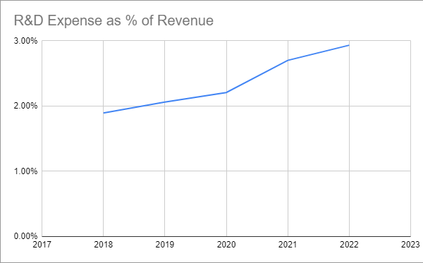

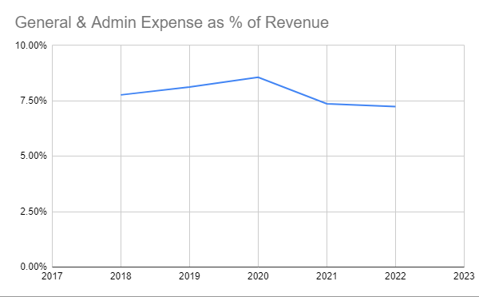

Over the course of the five year period from 2018 to 2022, Sleep Number’s revenue increased by $582 million. During the same period Sleep Number’s General and Administrative expenses as a percentage of revenue fell by 0.53 percentage points and Sleep Number’s Research and Development expenses as a percentage of revenue increased by 1.04 percentage points. For forecasting purposes, there is an expectation of a .09 percentage point decrease in General and Administrative expenses as a percentage of revenue and a .18 percentage point increase in Research and Development expenses as a percentage of revenue for every $100 million increase in Sleep Number’s revenue.

1. Historical Revenue Breakdown

|  |  |  |  |  |  |
| --- | --- | --- | --- | --- | --- |
|  | 2018 | 2019 | 2020 | 2021 | 2022 |
| Percent of Sales From Retail | 91.1% | 90.8% | 85.3% | 85.8% | 84.8% |
| Percent of Sales From Online and Other | 8.9% | 9.2% | 14.7% | 14.2% | 15.2% |

1. Intermediary Financial Forecast: Partnering with Amazon

Amazon’s mattress market is estimated to be $2.732 billion in 2023 and growing at 2.79%. This is depicted in the table below in billions of dollars.

|  |  |  |  |  |  |
| --- | --- | --- | --- | --- | --- |
|  | 2023 | 2024 | 2025 | 2026 | 2027 |
| Amazon’s Mattress Market | 2.732 | 2.808 | 2.887 | 2.967 | 3.050 |

This forecast is projecting Sleep Number to garner 4.9% of this market linearly by 2027. For this new revenue generated from the partnership with Amazon, the assumption is that there is going to be an additional 3% added to the cost of sales as a result of Amazon’s referral fee. This is depicted in the table below in billions of dollars.

|  |  |  |  |  |  |
| --- | --- | --- | --- | --- | --- |
|  | 2023 | 2024 | 2025 | 2026 | 2027 |
| Sales (Previous Channels) | 2.060 | 2.171 | 2.287 | 2.410 | 2.539 |
| Sales (Amazon) | 0.027 | 0.055 | 0.085 | 0.116 | 0.149 |
| Total Sales | 2.087 | 2.226 | 2.372 | 2.526 | 2.688 |
| Cost of Sales (Previous Channels) | 0.889 | 0.937 | 0.987 | 1.040 | 1.095 |
| Cost of Sales (Amazon) | 0.012 | 0.025 | 0.039 | 0.054 | 0.069 |
| Total Cost of Sales | 0.901 | 0.962 | 1.026 | 1.094 | 1.164 |
| Gross Profit | 1.186 | 1.264 | 1.346 | 1.432 | 1.524 |

The complete financial forecast following the implementation of a partnership with Amazon is depicted below with values in billions of dollars.

|  |  |  |  |  |  |  |  |  |  |  |
| --- | --- | --- | --- | --- | --- | --- | --- | --- | --- | --- |
|  | 2023 | % of sales | 2024 | % of sales | 2025 | % of sales | 2026 | % of sales | 2027 | % of sales |
| Net Sales | 2.087 | 100% | 2.226 | 100% | 2.372 | 100% | 2.526 | 100% | 2.688 | 100% |
| Cost of Sales | 0.901 | 43% | 0.962 | 43% | 1.026 | 43% | 1.094 | 43% | 1.164 | 43% |
| Gross Profit | 1.186 | 57% | 1.264 | 57% | 1.346 | 57% | 1.432 | 57% | 1.524 | 57% |
| Operating Expenses: |  |  |  |  |  |  |  |  |  |  |
| Sales and Marketing | 0.907 | 44% | 0.966 | 44% | 1.028 | 44% | 1.094 | 44% | 1.163 | 44% |
| General and Administrative | 0.152 | 7% | 0.159 | 7% | 0.166 | 7% | 0.173 | 7% | 0.181 | 7% |
| Research and Development | 0.060 | 3% | 0.070 | 3% | 0.081 | 3% | 0.093 | 4% | 0.107 | 4% |
| Total Operating Expenses | 1.119 | 54% | 1.195 | 54% | 1.275 | 54% | 1.360 | 55% | 1.451 | 55% |
| Operating Income | 0.067 | 3% | 0.069 | 3% | 0.071 | 3% | 0.072 | 3% | 0.073 | 3% |
| Interest Expense | 0.019 | 1% | 0.020 | 1% | 0.021 | 1% | 0.023 | 1% | 0.024 | 1% |
| Income Before Income Taxes | 0.048 | 3% | 0.049 | 3% | 0.050 | 3% | 0.049 | 2% | 0.049 | 2% |
| Income Tax Expense | 0.012 | 1% | 0.012 | 1% | 0.012 | 1% | 0.012 | 1% | 0.012 | 1% |
| Net Income | 0.036 | 2% | 0.037 | 2% | 0.038 | 2% | 0.037 | 1% | 0.037 | 1% |

This forecast continues with the assumption from the control forecast that for every $100 million increase in revenue, Sleep Number’s General and Administrative expenses will fall by .09 percentage points and Sleep Number will choose to increase Research and Development expenses by .18 percentage points. However this represents more of how one might predict Sleep Number to spend their additional money rather than how much additional money they are actually making. If Sleep Number were to choose to keep their Research and Development expenses at the same quantity as the control forecast, the forecasts do indeed indicate that Sleep Number would earn additional income with the Amazon partnership. The income statement with this in mind is depicted below in billions of dollars.

|  |  |  |  |  |  |  |  |  |  |  |
| --- | --- | --- | --- | --- | --- | --- | --- | --- | --- | --- |
|  | 2023 | % of sales | 2024 | % of sales | 2025 | % of sales | 2026 | % of sales | 2027 | % of sales |
| Net Sales | 2.087 | 100% | 2.226 | 100% | 2.372 | 100% | 2.526 | 100% | 2.688 | 100% |
| Cost of Sales | 0.901 | 43% | 0.962 | 43% | 1.026 | 43% | 1.094 | 43% | 1.164 | 43% |
| Gross Profit | 1.186 | 57% | 1.264 | 57% | 1.346 | 57% | 1.432 | 57% | 1.524 | 57% |
| Operating Expenses: |  |  |  |  |  |  |  |  |  |  |
| Sales and Marketing | 0.907 | 44% | 0.966 | 44% | 1.028 | 44% | 1.094 | 44% | 1.163 | 44% |
| General and Administrative | 0.152 | 7% | 0.159 | 7% | 0.166 | 7% | 0.173 | 7% | 0.181 | 7% |
| Research and Development | 0.058 | 3% | 0.066 | 3% | 0.074 | 3% | 0.084 | 3% | 0.094 | 3% |
| Total Operating Expenses | 1.117 | 54% | 1.191 | 54% | 1.268 | 54% | 1.351 | 54% | 1.438 | 54% |
| Operating Income | 0.069 | 3% | 0.073 | 3% | 0.078 | 3% | 0.081 | 3% | 0.086 | 3% |
| Interest Expense | 0.019 | 1% | 0.020 | 1% | 0.021 | 1% | 0.023 | 1% | 0.024 | 1% |
| Income Before Income Taxes | 0.050 | 2% | 0.053 | 2% | 0.057 | 2% | 0.058 | 2% | 0.062 | 2% |
| Income Tax Expense | 0.012 | 1% | 0.013 | 1% | 0.014 | 1% | 0.014 | 1% | 0.015 | 1% |
| Net Income | 0.038 | 2% | 0.040 | 2% | 0.043 | 2% | 0.044 | 2% | 0.047 | 2% |

1. Intermediary Financial Forecast: Launching a Mattress-in-a-Box Product

The size of the mattress-in-a-box market is estimated to be $1.637 billion in 2023 and growing at 2.79%. This is depicted in the table below in billions of dollars.

|  |  |  |  |  |  |
| --- | --- | --- | --- | --- | --- |
|  | 2023 | 2024 | 2025 | 2026 | 2027 |
| Mattress-in-a-Box Market | 1.637 | 1.683 | 1.730 | 1.778 | 1.827 |

This forecast is projecting Sleep Number to garner 17.9% of this market linearly by 2027. This is depicted in the table below in billions of dollars.

|  |  |  |  |  |  |
| --- | --- | --- | --- | --- | --- |
|  | 2023 | 2024 | 2025 | 2026 | 2027 |
| Sales (Previous Channels) | 2.060 | 2.171 | 2.287 | 2.410 | 2.539 |
| Sales (Mattress-in-a-Box) | 0.059 | 0.121 | 0.186 | 0.255 | 0.327 |
| Total Sales | 2.119 | 2.292 | 2.473 | 2.665 | 2.866 |
| Cost of Sales (Previous Channels) | 0.889 | 0.937 | 0.987 | 1.040 | 1.095 |
| Cost of Sales (Mattress-in-a-Box) | 0.025 | 0.052 | 0.080 | 0.110 | 0.141 |
| Total Cost of Sales | 0.914 | 0.989 | 1.067 | 1.150 | 1.236 |
| Gross Profit | 1.205 | 1.303 | 1.406 | 1.515 | 1.630 |

The complete financial forecast following the launch of a mattress-in-a-box product is depicted below with values in billions of dollars. It includes an additional $21 million in Research and Development expenses for the development of the product, and the interest expenses on that line of credit for one year. For the same reasons detailed in Appendix D, Research and Development expenses are not scaled up as revenue increases and are kept at the same level as the control forecast.

|  |  |  |  |  |  |  |  |  |  |  |
| --- | --- | --- | --- | --- | --- | --- | --- | --- | --- | --- |
|  | 2023 | % of sales | 2024 | % of sales | 2025 | % of sales | 2026 | % of sales | 2027 | % of sales |
| Net Sales | 2.119 | 100% | 2.292 | 100% | 2.473 | 100% | 2.665 | 100% | 2.866 | 100% |
| Cost of Sales | 0.914 | 43% | 0.989 | 43% | 1.067 | 43% | 1.150 | 43% | 1.236 | 43% |
| Gross Profit | 1.205 | 57% | 1.303 | 57% | 1.406 | 57% | 1.515 | 57% | 1.630 | 57% |
| Operating Expenses: |  |  |  |  |  |  |  |  |  |  |
| Sales and Marketing | 0.922 | 44% | 0.997 | 44% | 1.076 | 44% | 1.160 | 44% | 1.247 | 44% |
| General and Administrative | 0.153 | 7% | 0.162 | 7% | 0.171 | 7% | 0.180 | 7% | 0.188 | 6% |
| Research and Development | 0.079 | 4% | 0.066 | 3% | 0.074 | 3% | 0.084 | 3% | 0.094 | 3% |
| Total Operating Expenses | 1.154 | 55% | 1.225 | 54% | 1.321 | 54% | 1.424 | 54% | 1.529 | 53% |
| Operating Income | 0.051 | 2% | 0.078 | 3% | 0.085 | 3% | 0.091 | 3% | 0.101 | 4% |
| Interest Expense | 0.020 | 1% | 0.021 | 1% | 0.022 | 1% | 0.024 | 1% | 0.026 | 1% |
| Income Before Income Taxes | 0.031 | 1% | 0.057 | 2% | 0.063 | 2% | 0.067 | 2% | 0.075 | 3% |
| Income Tax Expense | 0.008 | 0% | 0.014 | 1% | 0.015 | 1% | 0.016 | 1% | 0.018 | 1% |
| Net Income | 0.023 | 1% | 0.043 | 2% | 0.048 | 2% | 0.051 | 2% | 0.057 | 2% |

1. Intermediary Financial Forecast: Partnering With Additional Hotels

This forecast is projecting Sleep Number to gain one new hotel partner per year for the next five years. Each partnership will include the purchase of 7500 beds at cost for the 50 properties and 150 rooms per property. Each partnership is also projected to create additional sales of $28 million; that is 7500 beds multiplied by 255 occupants per year divided by one in 84 occupants buying a mattress in the next month multiplied by .24 the percentage of occupants who will switch the mattress they will buy to a Sleep Number multiplied by $5403 the average price of a Sleep Number mattress [9]. This is shown in the table below in billions of dollars.

|  |  |  |  |  |  |
| --- | --- | --- | --- | --- | --- |
|  | 2023 | 2024 | 2025 | 2026 | 2027 |
| Sales (Previous Channels) | 2.060 | 2.171 | 2.287 | 2.410 | 2.539 |
| Sales (To Hotel) | 0.041 | 0.041 | 0.041 | 0.041 | 0.041 |
| Sales (To Hotel Occupants) | 0.028 | 0.056 | 0.084 | 0.112 | 0.140 |
| Total Sales | 2.129 | 2.268 | 2.412 | 2.563 | 2.720 |
| Cost of Sales (Previous Channels) | 0.889 | 0.937 | 0.987 | 1.040 | 1.095 |
| Cost of Sales (To Hotel) | 0.018 | 0.018 | 0.018 | 0.018 | 0.018 |
| Cost of Sales (To Hotel Occupants) | 0.012 | 0.024 | 0.036 | 0.048 | 0.060 |
| Total Cost of Sales | 0.919 | 0.979 | 1.041 | 1.106 | 1.173 |
| Gross Profit | 1.210 | 1.289 | 1.371 | 1.457 | 1.547 |

The complete financial forecast implementing the additional hotel partnership strategy is depicted below with values in billions of dollars.

|  |  |  |  |  |  |  |  |  |  |  |
| --- | --- | --- | --- | --- | --- | --- | --- | --- | --- | --- |
|  | 2023 | % of sales | 2024 | % of sales | 2025 | % of sales | 2026 | % of sales | 2027 | % of sales |
| Net Sales | 2.129 | 100% | 2.268 | 100% | 2.412 | 100% | 2.563 | 100% | 2.720 | 100% |
| Cost of Sales | 0.919 | 43% | 0.979 | 43% | 1.041 | 43% | 1.106 | 43% | 1.173 | 43% |
| Gross Profit | 1.210 | 57% | 1.289 | 57% | 1.371 | 57% | 1.457 | 57% | 1.547 | 57% |
| Operating Expenses: |  |  |  |  |  |  |  |  |  |  |
| Sales and Marketing | 0.927 | 44% | 0.987 | 44% | 1.050 | 44% | 1.115 | 44% | 1.184 | 44% |
| General and Administrative | 0.154 | 7% | 0.161 | 7% | 0.168 | 7% | 0.175 | 7% | 0.182 | 7% |
| Research and Development | 0.058 | 3% | 0.066 | 3% | 0.074 | 3% | 0.084 | 3% | 0.094 | 3% |
| Total Operating Expenses | 1.139 | 54% | 1.214 | 54% | 1.292 | 54% | 1.374 | 54% | 1.460 | 54% |
| Operating Income | 0.071 | 3% | 0.075 | 3% | 0.079 | 3% | 0.083 | 3% | 0.087 | 3% |
| Interest Expense | 0.019 | 1% | 0.020 | 1% | 0.022 | 1% | 0.023 | 1% | 0.024 | 1% |
| Income Before Income Taxes | 0.052 | 2% | 0.055 | 2% | 0.057 | 2% | 0.060 | 2% | 0.063 | 2% |
| Income Tax Expense | 0.012 | 1% | 0.013 | 1% | 0.014 | 1% | 0.014 | 1% | 0.015 | 1% |
| Net Income | 0.040 | 2% | 0.042 | 2% | 0.043 | 2% | 0.046 | 2% | 0.048 | 2% |

1. Historical Balance Sheets

Sleep Number’s balance sheets from the past five years are shown below with values in thousands of dollars [33] [34] [35] [36] [2].

|  |  |  |  |  |  |
| --- | --- | --- | --- | --- | --- |
|  | 2018 | 2019 | 2020 | 2021 | 2022 |
| Current Assets |  |  |  |  |  |
| Cash | 1,612 | 1,593 | 4,243 | 2,389 | 1,792 |
| Accounts Receivable | 24,795 | 19,978 | 31,871 | 25,718 | 26,005 |
| Inventories | 84,882 | 87,065 | 81,362 | 105,644 | 114,034 |
| Prepaid Expenses | 8,009 | 15,335 | 20,839 | 18,953 | 16,006 |
| Other | 31,559 | 36,397 | 43,489 | 54,917 | 39,921 |
| Total Current Assets | 150,857 | 160,368 | 181,804 | 207,621 | 197,758 |
| Non-Current Assets |  |  |  |  |  |
| Property and Equipment | 205,631 | 197,421 | 175,223 | 195,128 | 200,605 |
| Operating Lease Assets | 0 | 327,017 | 314,226 | 371,133 | 397,755 |
| Goodwill and Intangible Assets | 75,407 | 73,226 | 72,871 | 70,468 | 68,065 |
| Deferred Income Taxes | 0 | 0 | 0 | 0 | 7,958 |
| Other Non-Current Assets | 38,243 | 48,011 | 56,012 | 75,190 | 81,795 |
| Total Assets | 470,138 | 806,043 | 800,136 | 919,540 | 953,936 |
| Current Liabilities |  |  |  |  |  |
| Borrowings | 199,600 | 231,000 | 244,200 | 382,500 | 459,600 |
| Accounts Payable | 144,781 | 134,594 | 91,904 | 162,547 | 176,207 |
| Customer Prepayments | 27,066 | 34,248 | 72,017 | 129,499 | 73,181 |
| Accrued Sales Returns | 19,907 | 19,809 | 24,765 | 22,368 | 25,594 |
| Compensation and Benefits | 27,700 | 40,321 | 76,786 | 51,240 | 31,291 |
| Taxes and Withholding | 18,380 | 22,171 | 23,339 | 22,087 | 23,622 |
| Operating Lease Liabilities | 0 | 59,561 | 62,077 | 72,360 | 79,533 |
| Other Current Liabilities | 51,234 | 53,070 | 60,856 | 64,177 | 60,785 |
| Total Current Liabilities | 488,668 | 594,774 | 655,944 | 906,778 | 929,813 |
| Non-Current Liabilities |  |  |  |  |  |
| Deferred Income Taxes | 4,822 | 3,808 | 242 | 688 | 0 |
| Operating Lease Liabilities | 0 | 298,090 | 283,084 | 336,192 | 356,879 |
| Other Current Liabilities | 86,198 | 68,802 | 84,844 | 100,835 | 105,421 |
| Total Liabilities | 579,688 | 965,474 | 1,024,114 | 1,344,493 | 1,392,113 |
| Shareholders’ Deficit |  |  |  |  |  |
| Preferred Stock | 0 | 0 | 0 | 0 | 0 |
| Common Stock | 309 | 280 | 254 | 227 | 220 |
| Additional Paid-In Capital | 0 | 0 | 0 | 3,971 | 5,182 |
| Accumulated Deficit | -109,859 | -159,711 | -224,232 | -429,151 | -443,579 |
| Total Shareholders’ Deficit | -109,550 | -159,431 | -223,978 | -424,953 | -438,177 |
| Total L&SD | 470,138 | 806,043 | 800,136 | 919,540 | 953,936 |

1. Calculating Days Receivable and Days Payable

Sleep Number’s 2022 Accounts Receivable is listed as $26.005 million [9]. Sleep Number’s Average Daily Sales is $5.792 million, which is found by dividing Sleep Number’s 2022 Net Sales of $2.114 billion by the 365 days in a year [9]. Days Receivable is found to be 4.490 by dividing Accounts Receivable by Average Daily Sales.

Sleep Number’s 2022 Accounts Payable is listed as $176.207 million [9]. Sleep Number’s Days Payable is found by adding 2022 Sales and Marketing expenses of $920 million to General and Administrative expenses of $153 million, dividing that number by the 365 days in a year, and using the resulting number as the divisor for Accounts Payable. With this, Sleep Number’s Days Payable is found to be 59.940.

1. Balanced Scorecard

XI. BIBLIOGRAPHY

1. Capital IQ, *Public Company Profile: Sleep Number Corporation*, <https://www-capitaliq-com.ezproxy.sju.edu/CIQDotNet/company.aspx?companyId=34176>
2. Sleep Number Corporation, *2022 Form 10-K*, <https://my.apps.factset.com/viewer-fusion/?_doc_id=0001564590-19-004499&_doc_product=EDG&_doc_date=20190226&_doc_docfn=U2FsdGVkX19HaZju1lcG3lINUGEj4Mn%252ByK4kLIk1eSPTtCRdyg4vwJL62x5IKZyYHCJh4gcmlZgoW1cbcA%252B5aL72jHwxbPRsuKo2CH0roBM&_doc_headline=Sleep%2520Number%2520Corp%2520files%2520%2810-K%29%2520Basic%2520annual%2520filing%252C%2520for%2520period%2520end%252029-Dec-18%2520%28SNBR-US%29&_doc_rc=true&_app_id=Smart%2520Search&appSesGUID=B3BB79083E2B2636>
3. Sleep Number Corporation, *Meet the Future of Sleep and Wellness*, <https://jobs.sleepnumber.com/about-us>
4. Sleep Number Corporation, *SleepIQ Sleep Tracker*, <https://www.sleepnumber.com/pages/sleepiq-sleep-tracker>
5. Lencioni, P. M. (2002, July), “Make Your Values Mean Something,” *Harvard Business Review*, <https://hbr.org/2002/07/make-your-values-mean-something>
6. Sleep Number Corporation, *Discover the Sleep Number Difference*,<https://www.sleepnumber.com/>
7. Statista Research Department, “Average cost of a mattress in the U.S. in 2021 by type,” *Statista*, <https://www.statista.com/statistics/884834/average-unit-price-of-mattresses-and-motion-foundations-us/>
8. Sleep Number Support, *Shipping and Delivery Outside the United States*, <https://support.sleepnumber.com/hc/en-us/articles/233428307>
9. Sleep Number Corporation, *2022 Q3 10-Q*, <https://my.apps.factset.com/viewer/?_doc_id=0000827187-22-000067&_doc_date=20221108&_doc_product=EDG&_doc_docfn=U2FsdGVkX1%2Bv7fVzooFfG2%2BRS6Y0GgLJtZWsoQCnMyBTIF6vMq89hlLmEE4ZEBj%2F5rlp%2BGcAYdN%2FnjU4Cz8Ku1aJBK3Ghb01q7knxrJn9J8%3D&_doc_sequence=1&_doc_title=Sleep%20Number%20Corp%20files%20%2810-Q%29%20Basic%20quarterly%20filing,%20for%20period%20end%201-Oct-22%20%28SNBR-US%29&_doc_type=HTML>
10. O’Mara, S. L. (2023, February), “Who spends more for a mattress? Online or in-store consumers?,” *Furniture Today*, <https://www.furnituretoday.com/bedding-manufacturers/who-spends-more-for-a-mattress-online-or-in-store-consumers/>
11. Grand View Research, *Air Mattress Market Size Share & Trends Analysis Report By Product*, <https://www.grandviewresearch.com/industry-analysis/air-mattress-market>
12. Statista, *Consumer Market Insights: Mattresses - United States*, <https://www.statista.com/outlook/cmo/furniture/bedroom-furniture/mattresses/united-states>
13. Wu, J. (2019, August), “There are now 175 online mattress companies—and you can’t tell them apart,” *CNBC*, <https://www.cnbc.com/2019/08/18/there-are-now-175-online-mattress-companiesand-you-cant-tell-them-apart.html>
14. Barretta, A. (2023, March), “What mattresses do hotels use? The Ritz, Hilton, Premier Inn and more,” *Tom’s Guide*, [https://www.tomsguide.com/news/what-mattresses-do-hotels-use](https://www.tomsguide.com/news/what-mattresses-do-hotels-use#section-what-mattress-does-the-westin-hotel-use)
15. Smart Sleeping Tips, *Hotels with Sleep Number Beds*, <https://smartsleepingtips.com/hotels-with-sleep-number-beds/>
16. Bomey, N. (2022, April), “Chip shortage threatens mattresses: Sleep Number production suffering,” *Axios*, <https://www.axios.com/2022/04/30/sleep-number-mattress-bed-semiconductor-chip-shortage>
17. Coppola, D. (2023, April), “E-commerce as share of total U.S. retail sales from 1st quarter 2010 to 4th quarter 2022,” *Statista*, <https://www.statista.com/statistics/187439/share-of-e-commerce-sales-in-total-us-retail-sales-in-2010/>
18. Statista Research Department (2023, February), “Mobile commerce share of total digital commerce spending in the United States from 4th quarter 2017 to 4th quarter 2022,” *Statista*, <https://www-statista-com.ezproxy.sju.edu/statistics/252621/share-of-us-retail-e-commerce-dollars-spent-via-mobile-device/>
19. Pasquali, M. (2023, April), “Top online stores worldwide in 2021 by e-commerce net sales,” *Statista*, <https://www.statista.com/forecasts/860716/top-online-stores-global-ecommercedb>
20. Amazon, *Revenue Calculator,* <https://sellercentral.amazon.com/hz/fba/profitabilitycalculator/index?lang=en_US>
21. Hatchet-Cook, J. (2021, March), “What vendors need to know to negotiate with Amazon,” *Chain Store Age,* <https://chainstoreage.com/what-vendors-need-know-negotiate-amazon>
22. Clay, B. (2022, August), “What percentage of your budget should go toward SEO?,” *Search Engine Land*, <https://searchengineland.com/percentage-budget-seo-387020>
23. Federal Reserve Board (2023, April), *Selected Interest Rates*, <https://www.federalreserve.gov/releases/h15/>
24. Statista Research Department (2023, April), “Average number of rooms per hotel in the United States from 2017 to 2020 by chain type,” *Statista*, <https://www.statista.com/statistics/823786/average-number-of-rooms-per-hotel-by-chain-type/>
25. Foley, L. (2023, January), “When Should You Replace Your Mattress?,” *Sleep Foundation*, <https://www.sleepfoundation.org/mattress-information/when-should-you-replace-your-mattress>
26. Yahoo! Finance, *SNBR Analysis*, <https://finance.yahoo.com/quote/snbr/analysis/>
27. Chevalier S. (2022, August), “Biggest online retailers in the U.S. 2022 by market share,” *Statista*, <https://www.statista.com/statistics/274255/market-share-of-the-leading-retailers-in-us-e-commerce/>
28. Newcomer, L. (2022, January), “The Mattress Industry is Evolving for the Future: Statistics and Trends,” *Mattress Clarity*, <https://www.mattressclarity.com/news/mattress-industry-statistics/>
29. Kurnst, A. (2022, June), “Share of Americans who bought a mattress in the last 12 months in 2018 by age,” *Statista*, <https://www.statista.com/statistics/228844/people-living-in-households-that-bought-a-mattress-usa/>
30. Johnson, B. (2022, April), “Infographic: Consumer Sampling – How Trying Leads to Buying,” *Inspira Marketing*, <https://inspiramarketing.com/infographic-consumer-sampling-how-trying-leads-to-buying/>
31. Statista Research Department (2022, October), “Monthly occupancy rate of hotels in the United States from 2020 to 2022,” *Statista*, <https://www.statista.com/statistics/206546/us-hotels-occupancy-rate-by-month/>
32. Factset, *SNBR Snapshot*, <https://my.apps.factset.com/navigator/company-security/snapshot/SNBR-US>
33. Sleep Number Corporation, *2018 Form 10-K*,

<https://my.apps.factset.com/viewer-fusion/?_doc_id=0001564590-19-004499&_doc_product=EDG&_doc_date=20190226&_doc_docfn=U2FsdGVkX19HaZju1lcG3lINUGEj4Mn%252ByK4kLIk1eSPTtCRdyg4vwJL62x5IKZyYHCJh4gcmlZgoW1cbcA%252B5aL72jHwxbPRsuKo2CH0roBM&_doc_headline=Sleep%2520Number%2520Corp%2520files%2520%2810-K%29%2520Basic%2520annual%2520filing%252C%2520for%2520period%2520end%252029-Dec-18%2520%28SNBR-US%29&_doc_rc=true&_app_id=Smart%2520Search&appSesGUID=B3BB79083E2B2636>

1. Sleep Number Corporation, *2019 Form 10-K*,

<https://my.apps.factset.com/viewer-fusion/?_doc_id=0001564590-19-004499&_doc_product=EDG&_doc_date=20190226&_doc_docfn=U2FsdGVkX19HaZju1lcG3lINUGEj4Mn%252ByK4kLIk1eSPTtCRdyg4vwJL62x5IKZyYHCJh4gcmlZgoW1cbcA%252B5aL72jHwxbPRsuKo2CH0roBM&_doc_headline=Sleep%2520Number%2520Corp%2520files%2520%2810-K%29%2520Basic%2520annual%2520filing%252C%2520for%2520period%2520end%252029-Dec-18%2520%28SNBR-US%29&_doc_rc=true&_app_id=Smart%2520Search&appSesGUID=B3BB79083E2B2636>

1. Sleep Number Corporation, *2020 Form 10-K*,

<https://my.apps.factset.com/viewer-fusion/?_doc_id=0001564590-19-004499&_doc_product=EDG&_doc_date=20190226&_doc_docfn=U2FsdGVkX19HaZju1lcG3lINUGEj4Mn%252ByK4kLIk1eSPTtCRdyg4vwJL62x5IKZyYHCJh4gcmlZgoW1cbcA%252B5aL72jHwxbPRsuKo2CH0roBM&_doc_headline=Sleep%2520Number%2520Corp%2520files%2520%2810-K%29%2520Basic%2520annual%2520filing%252C%2520for%2520period%2520end%252029-Dec-18%2520%28SNBR-US%29&_doc_rc=true&_app_id=Smart%2520Search&appSesGUID=B3BB79083E2B2636>

1. Sleep Number Corporation, *2021 Form 10-K*,

<https://my.apps.factset.com/viewer-fusion/?_doc_id=0001564590-19-004499&_doc_product=EDG&_doc_date=20190226&_doc_docfn=U2FsdGVkX19HaZju1lcG3lINUGEj4Mn%252ByK4kLIk1eSPTtCRdyg4vwJL62x5IKZyYHCJh4gcmlZgoW1cbcA%252B5aL72jHwxbPRsuKo2CH0roBM&_doc_headline=Sleep%2520Number%2520Corp%2520files%2520%2810-K%29%2520Basic%2520annual%2520filing%252C%2520for%2520period%2520end%252029-Dec-18%2520%28SNBR-US%29&_doc_rc=true&_app_id=Smart%2520Search&appSesGUID=B3BB79083E2B2636>